Remember, the recipe is not a locked-in waterfall process!

* We can skip if we are not sure/stuck in a given step
* But do not do this often! Only do this if you are really stuck on a given step

The following example can demonstrate that you can skip or go back to some steps as the steps progress

**Signature, purpose, and stub**

Signature



Purpose



Stub



**Examples**



Run: 

* Solution: require the 2htdp/image function



Run again: 

Comment out stub, and label



**Inventory**

Template



Copy, comment out, and label the template

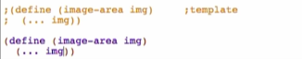

**Code Body**



Try running: 

But there is something to take note here:

* Pixels are always natural numbers! (non-negative numbers)
  + So we must make the signature more specific by modifying its return value to Natural



* + We want signatures to be as specific as possible! This will help us more in the later function definitions